MISSOURI CROWNS CO-CHAMPIONS
The Missouri State Tournament was held April 20 and 21, 2013 at the Rest Haven Convalescent & Retirement Home in Sedalia, Missouri. We were welcomed to the tournament by WAYNE MILLER, tournament sponsor, and LYNNE ROCKETT, Social Services Director of the nursing home. While we were waiting for the tournament to begin, Wilma Wolverton played an impromptu solo on the piano -- “The Star Spangled Banner“. What a great way to begin the day! We only had nine players attending the tournament. All were from Missouri except the winner of the tournament, BRYCE MORVILLE from Illinois. Congratulations, Bryce, on another great win for this year! Congratulation to our co-champions, DAVID DITTMAN and BILL WETHINGTON (his 8th state title)! The final exciting round left both players with 20 points and they were declared co-champions for 2013. IT IS INTERESTING TO NOTE THAT BOTH PLAYERS ALSO HAD 100 HONOR POINTS. Congratulations to our co-champions! We want to thank everyone for their donations. We were very sorry George Cook was unable to attend because of his father’s health. It’s always so good to see the wives who accompany their husbands and give them their moral support (Mary Morville, Candy Wait, and Darlene Stallsworth). George

TOURNAMENT RESULTS
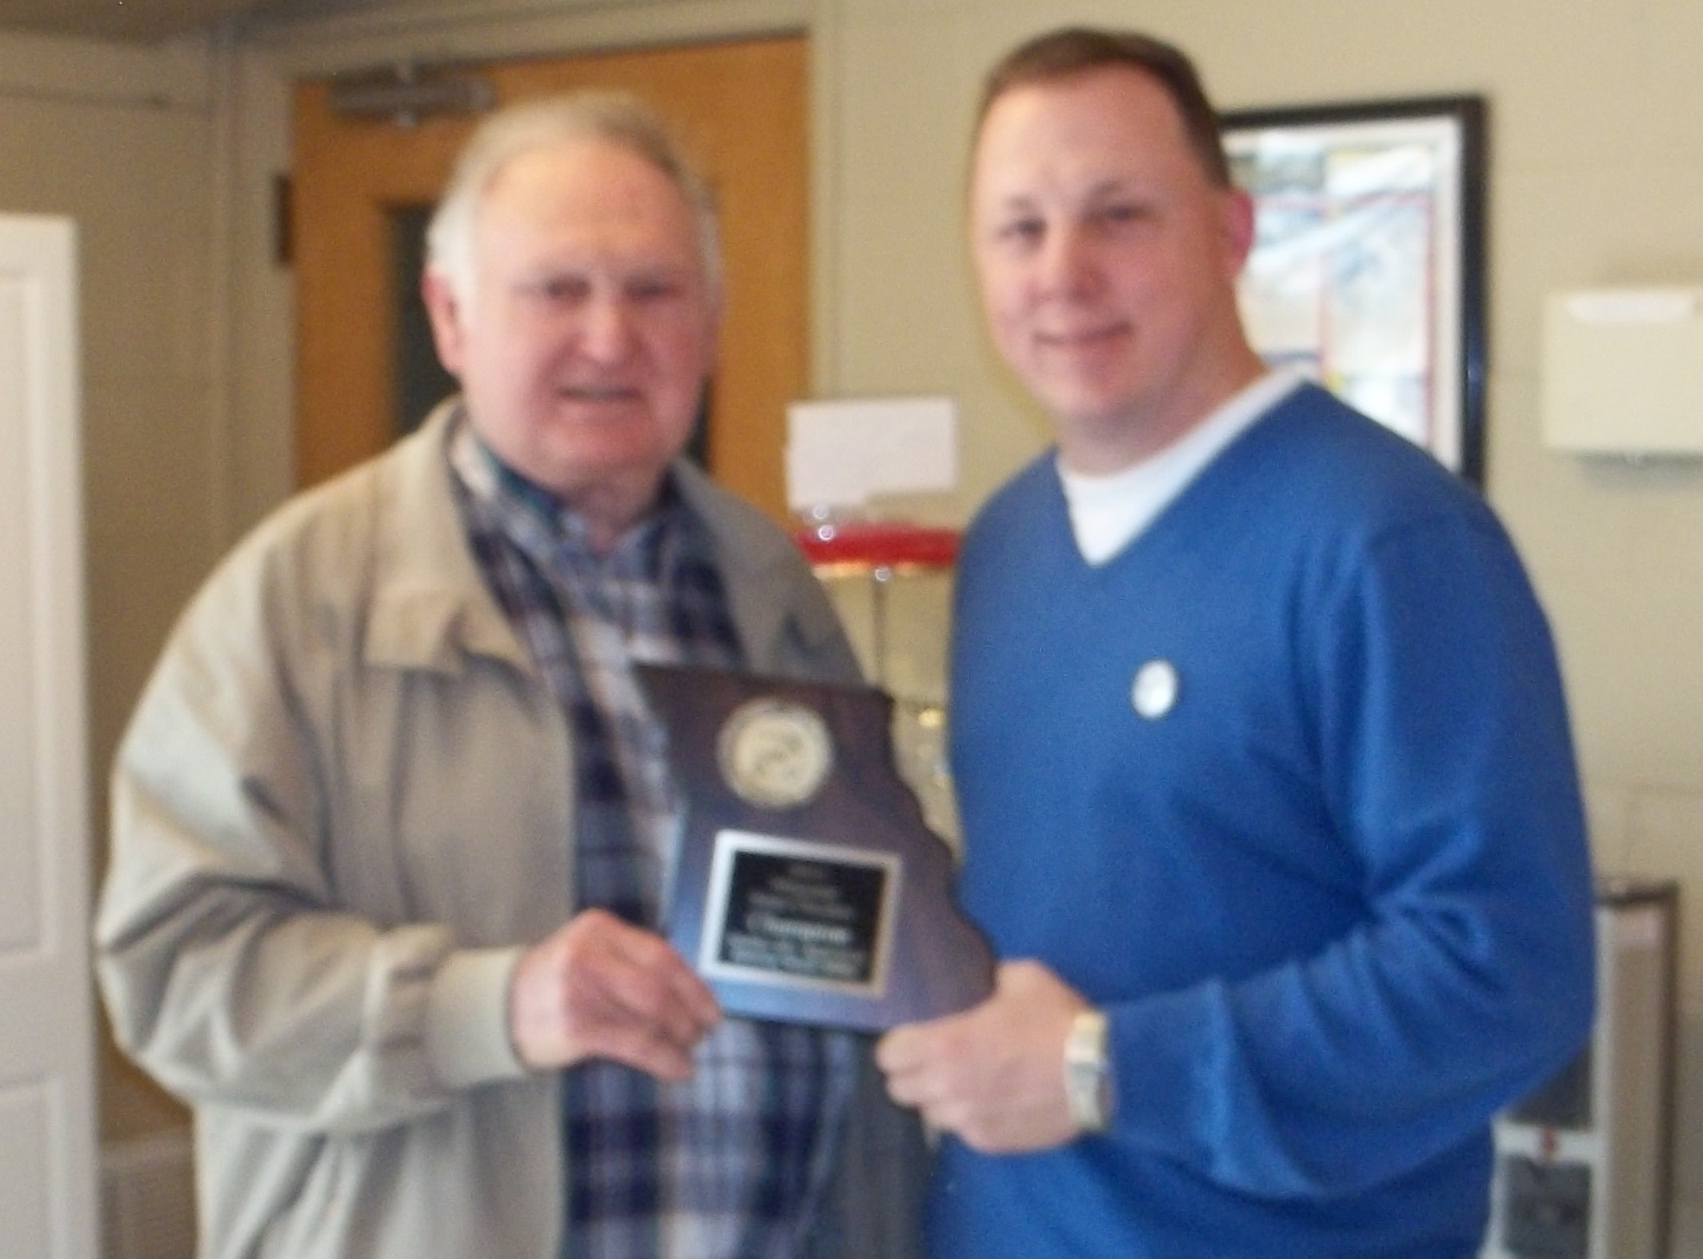
Finish Position Pts H Pts. Prize Fund
1. Bryce Morville 21 $125.00
2. David Dittman 20 100 87.50
Bill Wethington 20 100 87.50
4. Wayne Miller 16 60.00
5. Keith Wait 13 50.00
6. George Stallsworth 10 40.00
7. Wilma Wolverton 9 30.00
8. Chris Weiland 7 25.00
9. Richard Brownfield 3 20.00
TOTAL PRIZE FUND $525.00
Bill Wethington & David Dittman, Missouri Co-Champions

HOSTESS WITH THE MOSTESS
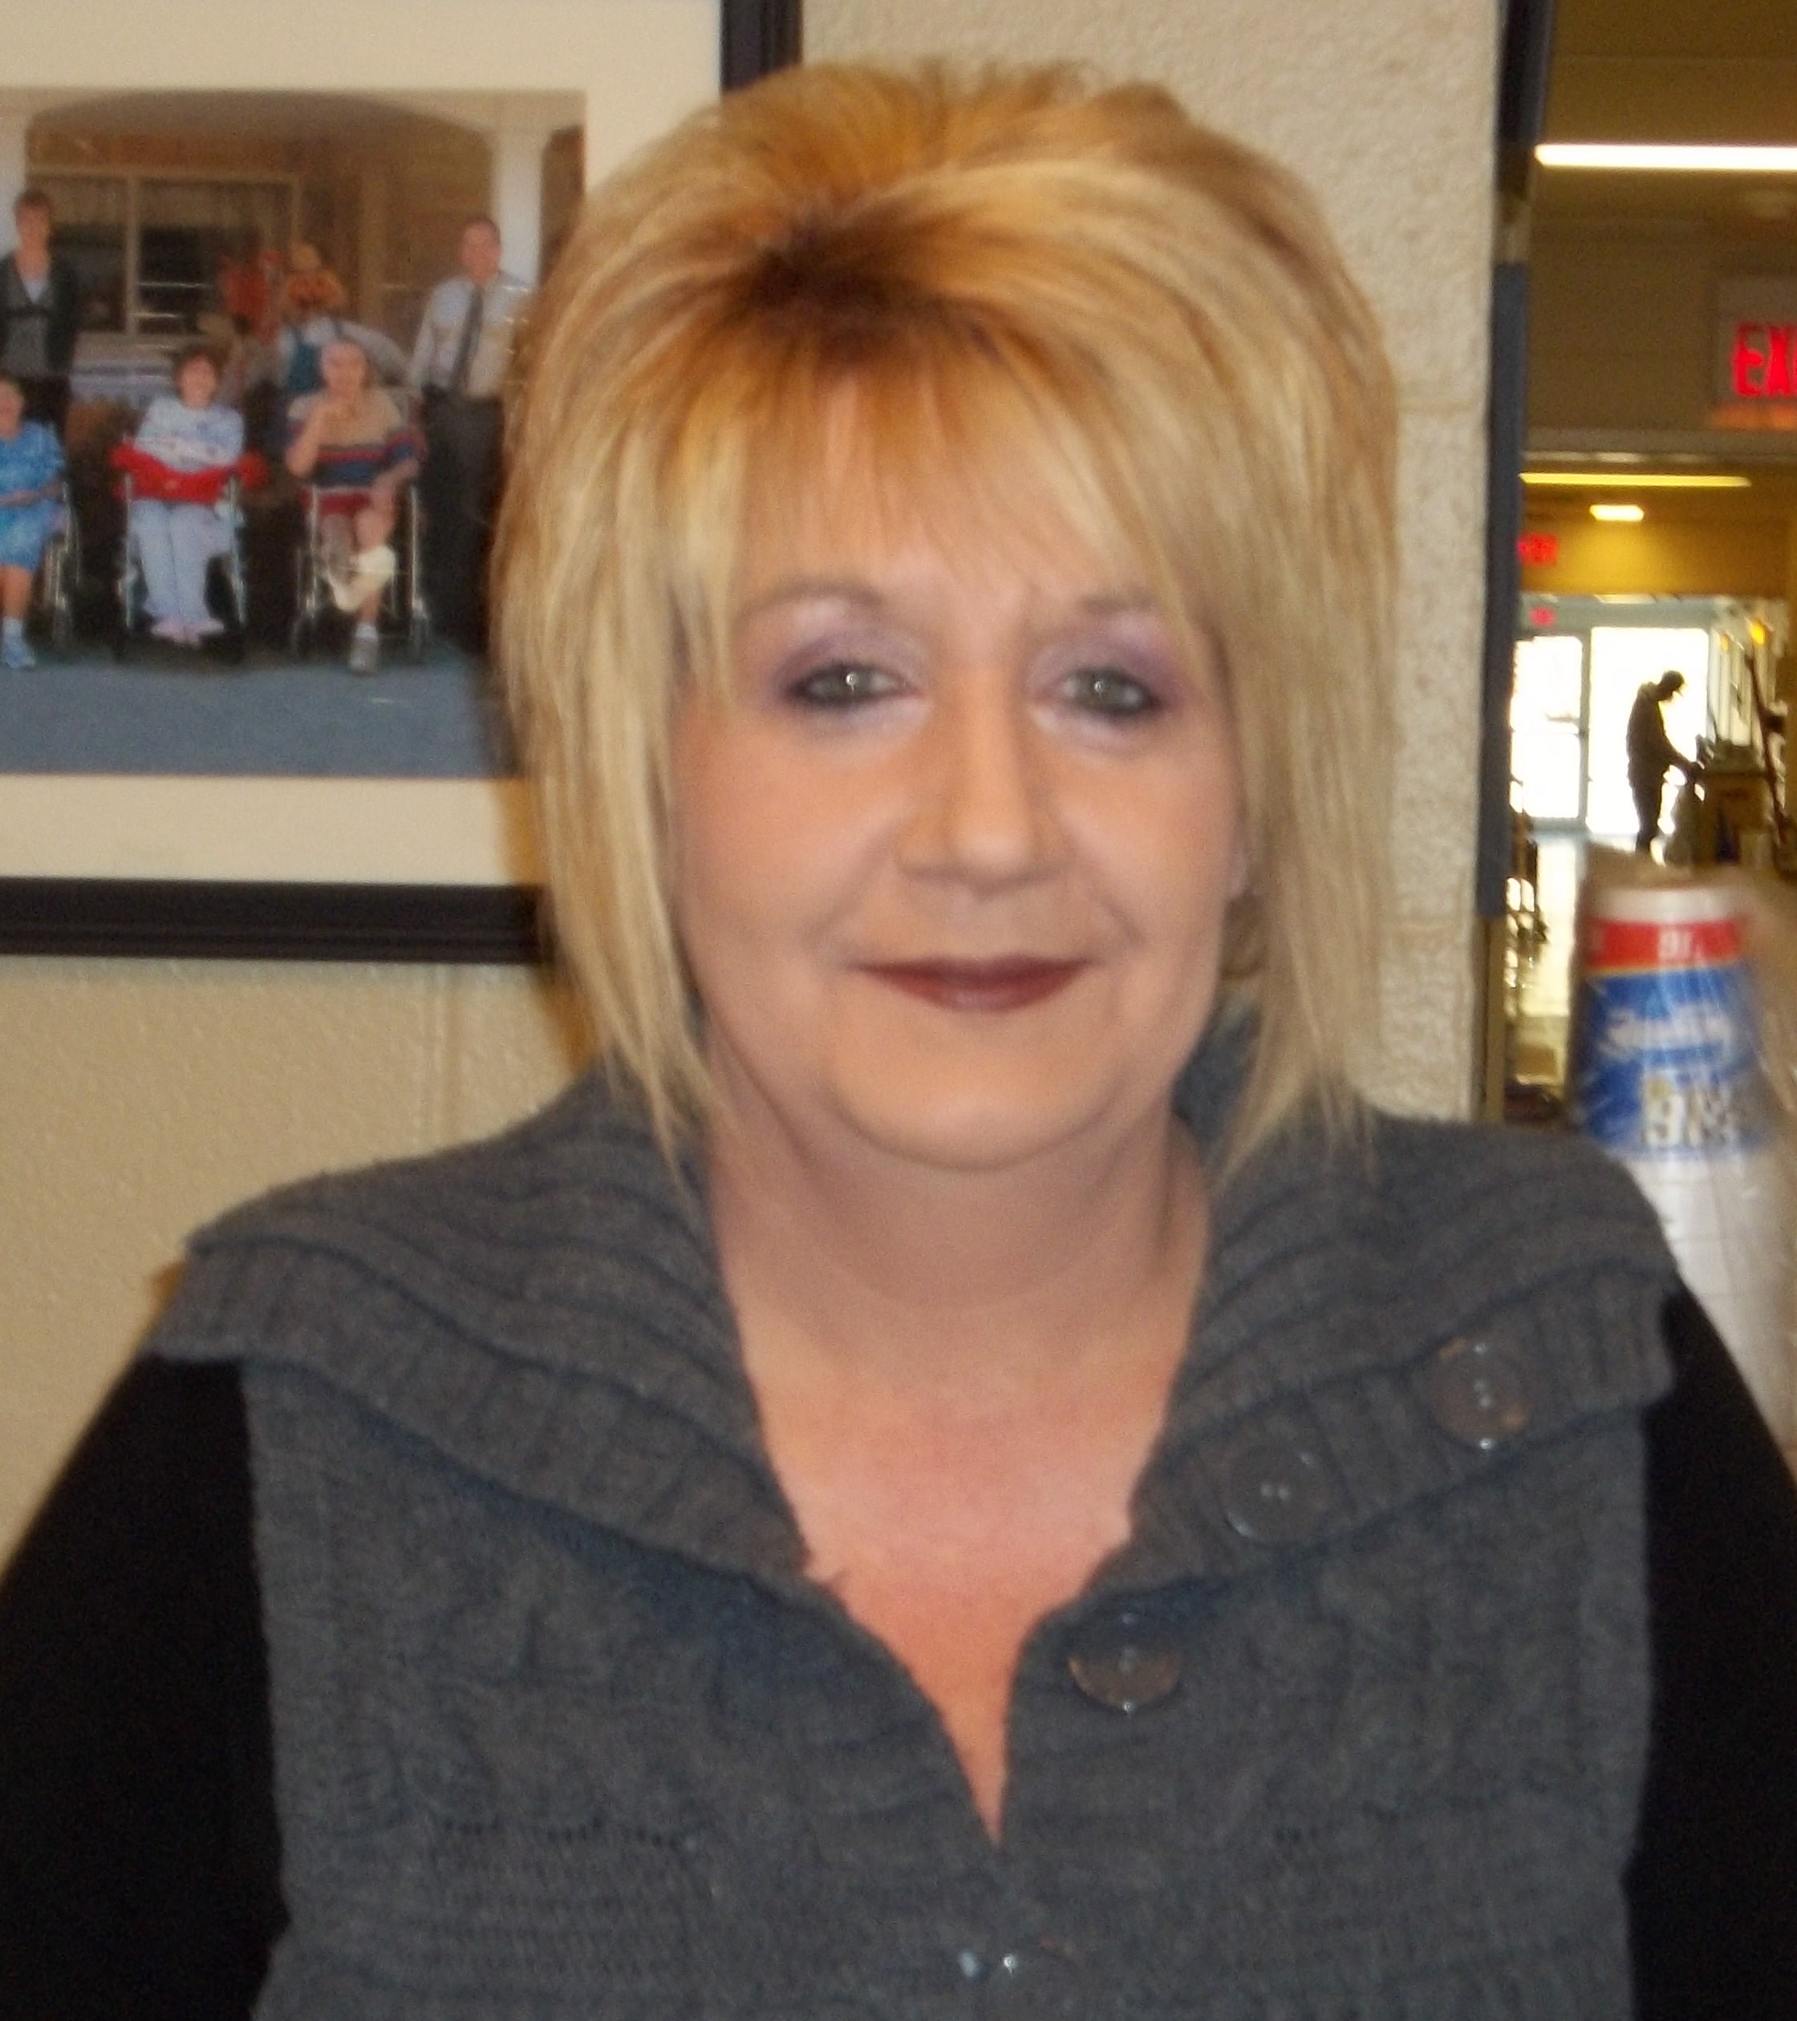 From the minute we entered the nursing home, we were greeted by Lynne Rockett with a smile. She went beyond anything we expected to see that we were comfortable and the playing room was quiet. Coffee and doughnuts were waiting for us on Saturday morning. For lunch, she provided homemade chili, hamburgers, hot dogs, chips, coffee and pop and apple pie. Sunday morning we arrived to find “hot from the oven” cookies including macadamia cookies (my favorite), doughnuts and coffee. Lynne, we can’t thank you enough for all your help in making this tournament so great. Thanks again, Lynne, all of us at the tournament really appreciated it.

